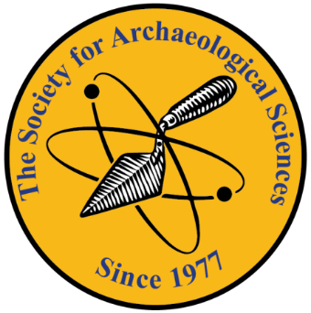
The Society for
Archaeological Sciences

Charles C. Kolb Award 2021

The Society for Archaeological Sciences (SAS) will offer one award every year for the best published paper on science-based archaeological research in ceramics in honor of Charles C. Kolb. The purpose of the award is to promote and acknowledge research excellence in the field of archaeological ceramics and highlight the key role of interdisciplinarity.

The award was established to honor Charles C. Kolb, a life member of the SAS for over 30 years, and dedicated editor of its Bulletin, for his intellectual contributions to ceramic studies, his significant role in communicating and transferring knowledge through his comprehensive reviews, and his continuous efforts to support new scholars.

Eligibility
Papers nominated for the award should be:
- peer-reviewed and accepted for publication in a journal or edited volume
- written in English

Assessment Criteria
All nominated papers will be assessed by a panel appointed by the SAS Executive Board, including at least two independent scholars, established experts in ceramic studies. The assessment of the nominated publications will be made by the evaluation panel primarily based on:
- Innovation and originality of the research
- Methodological contribution and/or advancement of innovative theoretical frameworks
- Impact or potential impact on the field of archaeological ceramics

Submission and Nomination
Papers can be nominated for the award upon being accepted for publication in a journal or edited volume. The nomination should be submitted by the author (if single-authored) or the corresponding author (if multi-authored) and should include:
- the attached “Charles C. Kolb Award 2021 - Paper Nomination Form” filled in
- a digital copy of the actual paper (as accepted for publication, including any additional material submitted), and
- proof of acceptance for publication, following peer review (email notification or other means sent by the editor of relevant journal or publisher, indicating that the article will be accepted in its current state for publication)
Nominations need to be sent to the SAS General Secretary (sasgensecretary@gmail.com).
Nominations will be considered once per year. Applications for papers accepted within 2021 should be submitted by 31 December 2021. The results will be announced by spring 2022 for the best 2021 paper.
The author(s) of the awarded article will receive a prize of USD $500. The SAS will contribute half of the monetary award, which is being matched by an anonymous donor. The awarded article will be promoted in the social media platforms linked to the SAS, as well as in the SAS bulletin.
Interested parties may contact Evangelia Kiriatzi, SAS President-elect (e.kiriatzi@bsa.ac.uk) for further information.

Charles C. Kolb Award 2021
Paper Nomination Form

Title of paper
Applicant | Name:  Affiliation:  Post address:  E-mail:  Contributor Role:
Second author | Name:  Affiliation:  Post address:  E-mail:  Contributor Role:
Third author | Name:  Affiliation:  Post address:  E-mail:  Contributor Role:
Fourth author | Name:  Affiliation:  Post address:  E-mail:  Contributor Role:
Fifth author | Name:  Affiliation:  Post address:  E-mail:  Contributor Role:
If more authors to add rows
Title of Journal/Book (if edited volume, give full reference)
Date of submission
Date of acceptance
Volume/issue (if journal)
DOI (if known)
Abstract | Please inset the abstract here

Acceptance date is based on the date listed on the email notification or other means sent by the editor of relevant journal, indicating that the article will be accepted in its current state for publication.

